#### **Introduction**

Welcome back! In the last Exercise, we talked about user personas and how important it is to keep your user in mind at every stage in the design process. With your proto-persona in hand, you should already have a good handle on what the main problem is that you need to address with your app, as well as some ideas on how to solve it. Don’t worry if your proto-persona is still a little rough around the edges; they aren’t static artifacts. You’ll keep refining your proto-persona as you gain a better understanding of your target audience.

Now that we’ve established “who” we’re designing for, let’s try to understand “how” they’ll engage with our content and navigate our vocabulary application. In the previous Exercise, we began working in the conceptualization phase of the design thinking process with POV. In this Exercise, we'll be taking your ideas a step further into conceptualization with “ideate.” We’ll be coming up with some initial thoughts on how to organize content and present information to our users.

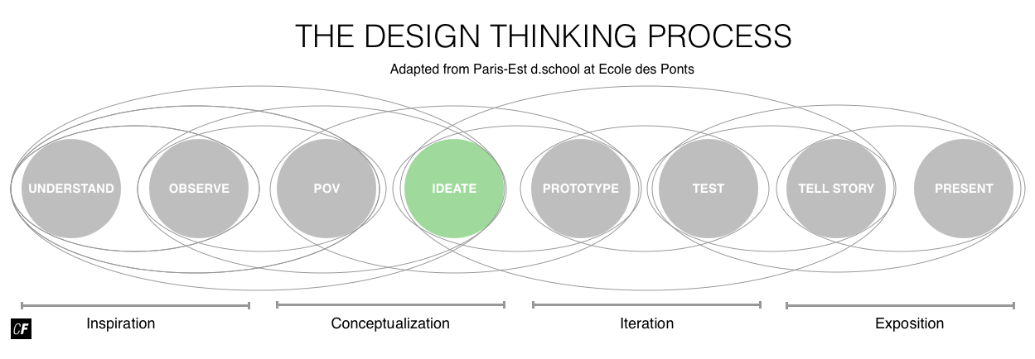

We’ll start by taking a look at the concept of **information architecture**, which refers to the organization of information within a system. In a website, for example, this refers to how content is grouped and navigated on a site. It's a critical component of the overall user experience. Once we’ve explored how information architecture is used to create a well-organized space, we’ll look into how users flow through that space to complete the main tasks necessary to address our problem statement. Naturally, these are called **user flows**, and you'll find an instructional video within the Exercise walking you through how to create your own user flow diagram. Finally, we’ll spend some time tackling **task analyses** to make sure we’ve considered all of the possible information and navigational issues surrounding the completion of a particular task. This information will come in handy in the next Exercise when you begin sketching your app.

#### **Intro to Information Architecture**

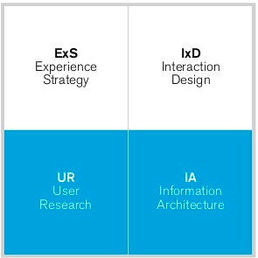

###### **Source:**[**Jason Mesut**](https://www.slideshare.net/planstrategic/ux-hiring-hq)

If you think back to our **quadrant model**, you’ll remember that information architecture is one of the four main quadrants, making it a major part of user experience design. Information architecture is heavily influenced by and related to user research, and we’ll use some more advanced user research methods to better inform the information architecture of our app.

Let’s begin by breaking down information architecture (commonly referred to as “IA”) into its two major components—information and architecture. According to the Oxford dictionary, the two words can be defined as such:

**Information:** what is conveyed or represented by a particular arrangement or sequence of things.

**Architecture:** the complex or carefully designed structure of something.

Now, if we combine these two words, we arrive at **information architecture (IA)**: a complex or carefully designed structure that’s conveyed or represented by a particular arrangement or sequence of things. The Information Architecture Institute integrates a more modern context into its definition of information architecture: “[IA] is about helping people understand their surroundings and find what they’re looking for, in the real world as well as online.”

In UX, information architecture refers to the structure of a website or app in both physical and digital forms. It’s a way to help users understand where they are in a particular product, as well as how to get where they want to be. Think about a website you use frequently or simply refer to the image below. What different areas does it have and how do you get to them? How does the homepage help you navigate to different pages, and how is the content organized into groups? By topic, purpose, or popularity?

These concepts all exist under the umbrella of information architecture. To get a better idea about the field, let’s take a look at how IA came into being, as well as how it’s progressed into the digital realm.

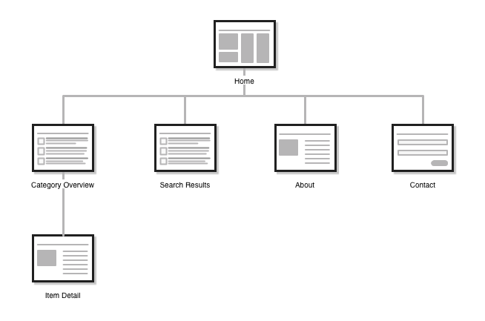

###### **Look familiar? This is a simple version of the humble sitemap. Sitemaps are just one way in which Information Architects communicate structure in a digital context.**[**Click here**](https://coach-courses-us.s3.amazonaws.com/public/courses/ux-fundamentals/E4/image_04_sitemap.png)**to zoom in.**

##### **A Brief History of IA**

Ever since Gutenberg invented the printing press in 1440, global access to books and information has exploded. With the birth of the internet, that access has jumped even higher. More than ever, we need systems to organize and categorize information if we're going to be able to find anything.

Humans naturally organize their surroundings in ways that are meaningful to them. For example, think about how we organize our personal library and arrange our living room. Doing so helps us make sense of our environment. Information architects (or IAs) play a very similar role and have, at times, referred to themselves as “**Architects of Understanding**.” They come from a variety of disciplines. Let's take a look below!

**Library science** in its most essential form is the study and implementation of “knowledge-organization systems.” Traditional libraries, museums, science labs, and hospitals utilize library science when organizing and cataloging information, books, and resources. Remember the Dewey Decimal System at your school or local library? It’s a means of numbering and cataloging every book in a way that corresponds to its physical location in the library. This is just one way humans have tried to cope with storing and accessing massive amounts of information.



Similarly, **cognitive psychology** involves the study of mental processes such as mental models (we’ll talk about these later) and cognitive load. Information architects are especially interested in the processes of memory, language use, and perception. These processes are what form the lens, or mental model, through which our customers perceive our product or service.

**Architecture**, as we mentioned, refers to the complex or carefully designed structure of something. In the traditional sense, this refers to the construction of physical spaces, from small cabins to skyscrapers. In each case, the architect needs to have a deep understanding of the building’s purpose. A solid grasp of how people will flow through the physical space of that building is also essential. It’s equally as important in digital spaces that we understand and anticipate the desired flow of users through the information.

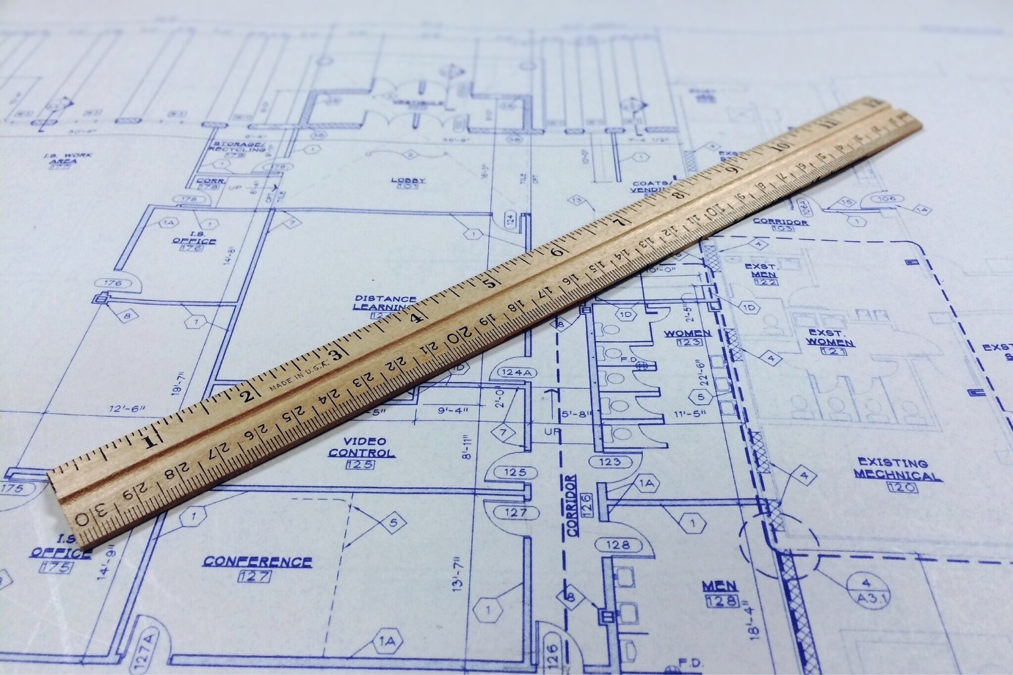

The term “information architecture” was first coined by architect Richard Saul Wurman in the 1970s. He managed to escape the traditional definition of architects and venture into the architecture of concepts and meaning. He argued that the organization of information was often more important than the information itself. Put in architectural terms, he believed that a solid blueprint was just as important as the materials. Richard Saul Wurman is still making connections today as the founder of TED Conferences. It would seem concepts and ideas are not only worth organizing, but also worth spreading.

Let’s move on to 1998, when a small company had just made it their mission to “organize the world’s information and make it universally accessible and useful.” That company was Google.

That same year, Louis Rosenfeld and Peter Morville published the book [*Information Architecture for the World Wide Web*](http://shop.oreilly.com/product/9780596527341.do), a modern take on organizing information in the digital age. This book is universally and affectionately called “The Polar Bear Book” due to the big white polar bear sauntering across the cover. It’s a must-read for anyone looking to learn the fundamentals of information architecture.



LEARN MORE!  
To develop a deeper understanding of information architecture, take four minutes to watch Dan Klyn’s Video: “[Explaining Information Architecture](https://vimeo.com/8866160).” It reiterates some of the concepts we discussed above while touching on a few new concepts such as ontology, taxonomy, and choreography.

#### **Mental Models**

A **mental model** is what someone believes about a particular system or concept. These models can vary wildly from person to person, especially when considering cultural or demographic differences. They are, therefore, beliefs—not facts. It’s important for designers to recognize the gap between their own mental model and the mental models of others, as a disconnect would sabotage their mission to “help people find things.” Why does this matter when designing an app or website? Let’s explore an example.

What do you imagine when you think about “breakfast”? Is it an important meal? Is it savory or sweet? Does it consist of a single cup of coffee on the way to the office or a full spread of meat, bread, and cheese? Your concept of breakfast likely depends on your geographic location and cultural upbringing. Culinary cultural differences make the world more interesting and delicious but can also lead to dissonances in understanding.

Imagine for a moment that you’re a European leading the global launch of a massive online supermarket. You carefully design every element of the site, from the logo to the checkout process. The launch goes live to great success, but you soon notice certain countries in Asia have no interest in the “breakfast” section of your online supermarket. Why is that? Is it because they don’t eat breakfast? Probably not. It’s not so much that they don’t enjoy breakfast, but that their idea of “breakfast” differs from a European idea of breakfast. In this case, there's been a failure to understand their concept of breakfast, leading to a disconnect between the design and their mental model.

JUST FOR FUN: BREAKFAST AROUND THE WORLD  
We all have our own unique mental models through which we observe and engage with the world. Even a simple concept like “breakfast” can have many different meanings depending on one’s culture and context. For a great visual on this exact phenomenon (and a fun break from the density of information architecture), check out this video on “[What the World Eats for Breakfast](https://www.youtube.com/watch?v=ry1E1uzPSU0).”

If you’re feeling a little hungry by now, we can’t blame you. All joking aside, you can see how your users’ mental models can have a large impact on the way you design the information architecture of your project. This is why it’s so critical to create a persona and continue doing user research as you progress through the design process. In the following sections, we’ll take a look at two common IA techniques that will help us thoroughly investigate the mental models of intended users and anticipate the flow of tasks they’d need to complete.

#### **Common IA Techniques: Card Sorts**

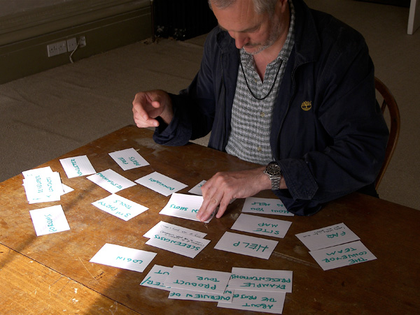

###### **Source:**[**Yandle**](https://www.flickr.com/photos/yandle/907104063/)

**Card sorting** (or a **card sort**) is a participatory design method used to help evaluate or generate ideas for the information architecture of a product or service. During a card sorting session, researchers ask participants to organize words or concepts into categories that make sense to them, giving the researcher a glimpse into their mental model. It’s a great way to construct the basic structure of your site based on real user feedback, from what to put on the homepage to the labels used for categories and navigation.

**Open card sorts** require participants to not only sort concepts into categories, but also to label these categories. This is a generative approach, as it generates new ideas on how to categorize and label concepts.



**Closed card sorts** provide the category labels for participants ahead of time, prompting the participant to sort concepts into existing categories. This is an evaluative approach, aimed at evaluating whether or not you’ve labeled categories properly.



How exactly does one go about conducting a card sort? The process itself is relatively quick and can be fun for both you and your participants. All you need is a marker or pen, some small pieces of paper (sticky notes or index cards work well), and a small group of people (three is usually a good place to start). Your goal is to see how your users interact with the information you’re considering for your app or site.

For example, let’s consider the online supermarket we were discussing above. How would you organize your supermarket? What sections would you create? Produce, dessert, breakfast, cheese, meat, and fish? And what about additional features like checkout, search, member profile, account password, and special offers?

To do an open card sort, you’d write these concepts on your pieces of paper and have your participants sort what they consider to be related cards into piles. When they’re done sorting the cards, you’d have them create a label for each stack. In a closed card sort, you’d provide the initial stack labels, and the participants would sort the cards into those categories. For example, you might provide your participants with categories like “Fresh Food,” “Deli,” “Packaged Foods,” and so on.

CARD SORT VIDEO  
For the more visually-inclined, check out [this video](https://www.youtube.com/embed/70QziJYQZoI) to see a card sort in action.

The goal of a card sort is to identify the consistent elements that come out of the results you collect. You want to determine how your users look at your product or service and investigate their mental models so as to present your information to them in an optimal way. This ensures a good flow of information and a smooth navigation experience. In the example above, if your users are putting cheese, meat, and fish together with produce (separate from your dessert and breakfast sections), this might give you some ideas as to how and where to present these categories.

TIP!  
Optimal Workshop offers some nice digital tools to help you conduct your own card sort online. Check it out here: [Optimal Sort Card Sort](https://www.optimalworkshop.com/optimalsort).

#### **Common IA Techniques: Task Analysis and User Flows**

Now that we’ve gotten ourselves into the architectural mindset, it’s time to dig a bit deeper into the complicated web of information architecture. Many of the seemingly simple routines we perform in our daily lives, both in the physical and digital worlds, are more complex than they seem at first glance. Every one of them is comprised of a multitude of small steps and decisions. When designing the information space for your product or service, it’s critical that we break down tasks into these same tiny steps so we can identify important decisions and potential points of friction.

Card sorts help us determine how best to organize our projects and group concepts, but we also need to know the exact actions our users will take to accomplish the tasks in our product. We can do this using something called **task analysis**: firstly, it’s concerned with identifying which tasks users will need to do when they use a particular product; for example, adding an item to a shopping cart on an ecommerce site. Secondly, task analysis breaks down each of these tasks into granular steps.

Taking the example of adding an item to an online shopping cart, this might involve selecting the quantity, size, or color of the item before clicking on the button to add it to the shopping cart. To conduct a task analysis, start by honing in on a specific task to analyze. Determine the **entry point** (where the user would first encounter the task) and a set of **success criteria** (what successful completion of the task would look like). Let’s take a look at an example:

**Task Analysis: Make a Cup of Tea**  
(a seemingly simple task that is more complicated than it seems)

Entry Point: Locate the kettle  
Success Criteria: Enjoy a cup of tea

* Decide how many cups of tea to make
* Fill the kettle with water
* Put the kettle on the stove
* Select tea bag(s)
* Choose mug(s)
* Place the tea bag in the mug
* Determine if the water is boiling. If not, wait. If so, pick up the kettle and pour the water into the mug
* Pour milk into tea (if so desired)
* Wait for the tea to steep (the exact number of minutes will depend on the tea you chose)
* Success criteria: enjoy a well-brewed cup of tea!

Now, let’s think back to your own project. What types of tasks will your users want to accomplish using your app? Will they want to add vocabulary words and definitions? What about logging into your app via their device? Just as with the cup of tea example, these are seemingly simple tasks that grow in complexity once you’ve considered all of the minute steps they require to reach completion.

**User flows**, on the other hand, set out the paths that users will follow to navigate through a website or app in order to achieve their goals. Each user may choose to take a different path depending on their information needs and goals, following a path that leads them from one task to the next, and perhaps stopping to find different pieces of information on their way. When mapping out your user flows, you should also refer back to the user stories you’ve written previously because they enable you to focus on the functions and solutions from the perspective of your persona.

For example, let’s pretend you have a friend named Richie who’d like to make a cup of tea. Take a look at the [user flow we’ve created](https://coach-courses-us.s3.amazonaws.com/public/courses/ux-fundamentals/E4/image_04_userflow_tea.png). Notice that the quickest and most effective path has been highlighted. This is called the “happy path.” The major decision points are represented as diamonds and can create feedback loops depending on the particular situation. In user flows, decisions are always stated as questions from the user’s perspective, and their answers must be binary (only include two options). As scrolling down tends to be easier than scrolling side-to-side, most user flows are represented vertically.

In a digital context like your project, you’re more likely to encounter tasks such as logging in, accessing saved flashcards, or adding a new flashcard. If you were designing a website, you might also consider issues such as link-backs, or how a user discovers your site (through an ad, from a list of search results, through a direct link, etc.), and how this impacts their experience upon reaching your site. Here’s an example of a user flow for Lingoda, an online language learning platform.

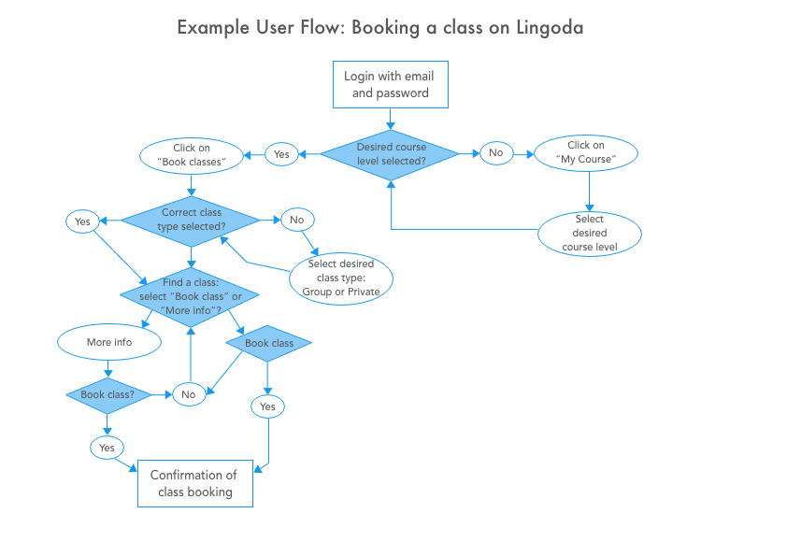

###### [**Click here**](https://coach-courses-us.s3.amazonaws.com/public/courses/ux-fundamentals/E4/image_04_userflow_lingoda.png)**to zoom in**

Bear in mind that your user flow doesn’t have to be created digitally. Using pen and paper can work just as well when you’re ideating on how your users will flow through your app to complete their tasks. In the instructional video below, your instructor, Claire, will create a user flow for her alarm clock app. Notice how she considers that her users might want to move backwards in the user flow, as well as forward!

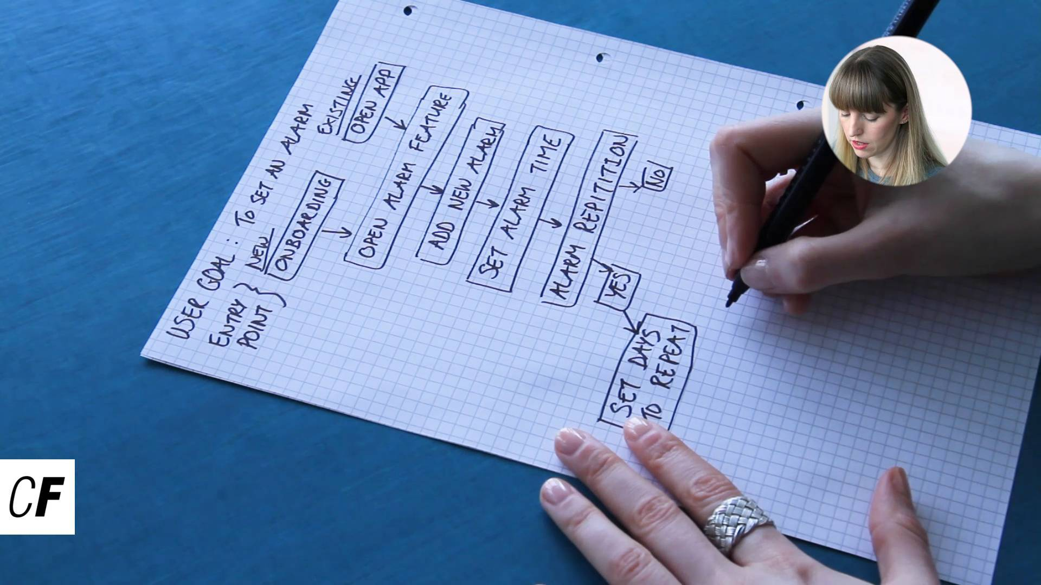

To sum up, user flows provide the high-level overview of how users navigate through a website or app, while task analysis allows us to delve deeper into the tasks that users need to complete along with the steps that make up each task. Whether you start with defining user flows or task analysis is dependent on the nature of the project you are working on. If you are designing a new product from scratch, you might first choose to define the tasks that your user persona would need to complete in order to achieve the goals they have for using your product. Conversely, if you are looking to improve the user experience of an existing product, you might be more interested in first looking at the user flows to see if users are having a hard time getting from one task to the next or are reaching “dead ends.” Whichever you choose to start with, user flows or task analysis, each process will inform and support the other.

There are many tools you can use for creating user flows, from sticky notes, to a variety of online tools. Any tool that allows you to make shapes, draw lines, and add text is all you need. As mentioned, that includes pen and paper, too! Here are a few of our favorites:

* PowerPoint or Keynote
* Sketch or other design software
* [Draw.io](https://www.draw.io/): This tool is completely free and can be accessed via your browser. It feels familiar to users of Google Documents.
* [Google Drawings](https://docs.google.com/drawings/): Another completely free tool that can be accessed via your browser. It’s intuitive for users who are familiar with Google Documents.
* [Lucidchart](https://www.lucidchart.com/): This tool includes a free version and focuses on diagrams, including several shapes ready to be dragged into the working canvas.
* [Overflow](https://overflow.io/): This is a new tool from proto.io that has not yet been fully released. You can currently download the beta version for free.
* [FlowMapp](https://flowmapp.com/): Another free tool that allows you to easily create and share a flowchart such as a user flow diagram.

#### **Summary**

In this Exercise, we explored the concept of information architecture, or how information is organized in a particular space. Information architecture is a critical aspect of user experience design, as it impacts how users move through your website, app, or other experience. Good information architecture is key to having happy users who can get to what they want, when they want it. How do you go about laying out your information structure? Designers use many techniques to help with this, including **card sorts**, in which participants sort relevant concepts into related groups, **task analyses**, in which you must closely consider the steps users must follow to complete tasks in your project, and **user flows**, which set out the paths that users will follow in order to achieve their goals. Taken together, these techniques will help you create a strong foundation for the structure of your design project.

Information architecture is a fascinating and dense topic, and there are many other techniques available for laying out your design. If you want to learn more, check out the additional resources listed below. In the meantime, let’s get started on implementing what we learned in this Exercise in your own project.

#### **Resources**

* [Beginners Guide to Information Architecture: UXBooth](http://www.uxbooth.com/articles/complete-beginners-guide-to-information-architecture/)
* [Introduction to Information Architecture: SmartInsights](http://www.smartinsights.com/user-experience/information-architecture-user-experience-persuasion-marketing/introduction-information-architecture/)
* [Mental Models: NNGroup](https://www.nngroup.com/articles/mental-models/)
* [A Brief History of Information Architecture: Journal of IA](http://journalofia.org/volume3/issue2/03-resmini/)
* [What Do the Different Flowchart Shapes Mean?](https://www.rff.com/flowchart_shapes.php)
* [SmartDraw: Flowchart Symbols](https://www.smartdraw.com/flowchart/flowchart-symbols.htm)
* [LucidChart: Flowchart Symbols and Notation](https://www.lucidchart.com/pages/flowchart-symbols-meaning-explained)